- Purpose
  - The purpose of this document is to describe the procedure for assembling the Disk Head on the Genesys Machine.
- Scope
  - This SOP applies to all equipment assembly team members. The process applies to the following machine ID’s:
EP50288EQS0600BE1200 – 20” Disc Head Assembly
EP50359EQS0600BE1200 – 20” Disc Head Assembly Pad Assist
- Responsibilities
  - The operations manager/supervisor is responsible for enforcing this SOP.
- Materials
  - The proper materials needed for this process are listed on the machine work order.
- Definitions

- Procedure
  - Start the head assembly by placing the proper sized weldment (E28855) on the table.
  - Attach the proper disk head shroud (E28881) to the weldment using 2 bolts (E81089) and 2 washers (E28622). Sitting the assembly on the blocks will make this easier. You may need to tap out the holes (5/16-18 tap) to be able to thread the bolts in.
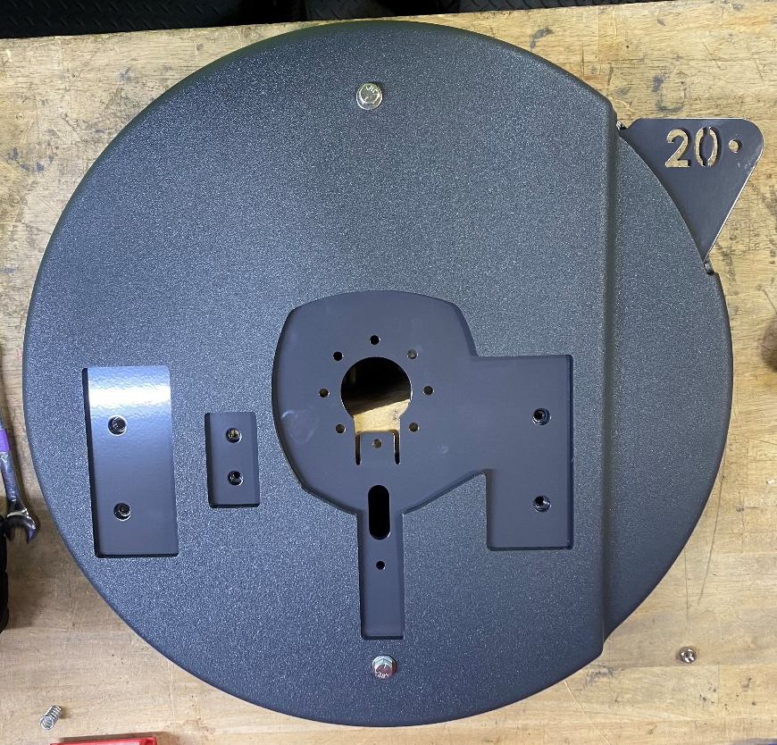
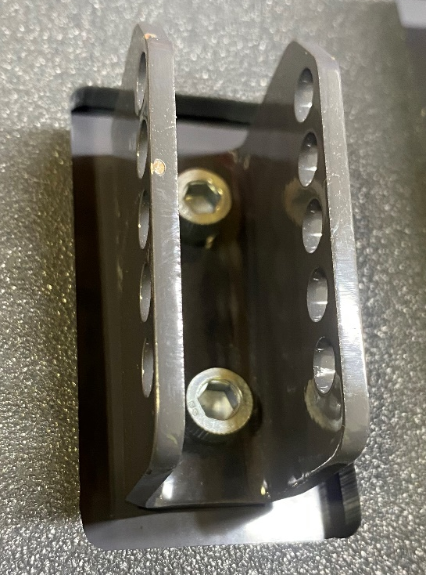
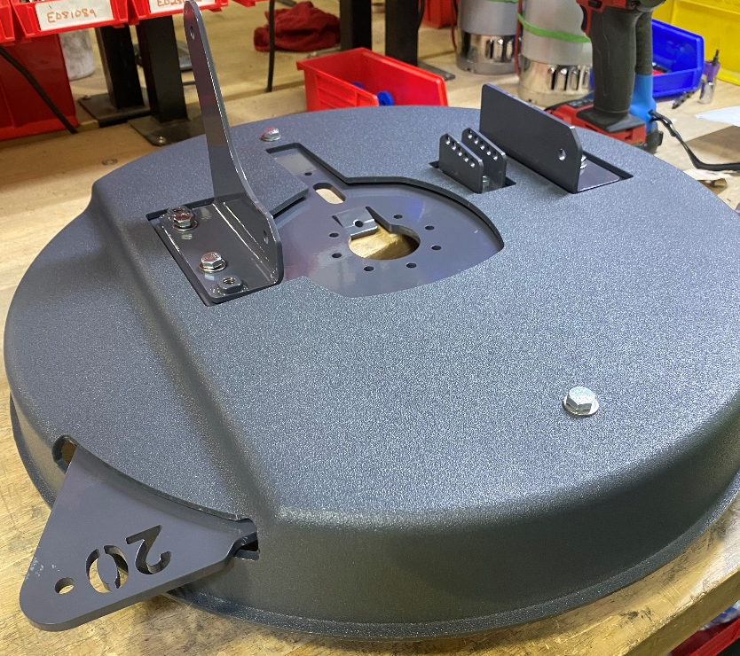
  - Attach two lift arm pivot brackets right hand (E28859) and left hand (E28860) using 2 hex bolts (E81089) and 2 washers (E28622) on each bracket. Check the bolt threads before placing blue Loctite on the bolts. For a transaxle machine, place bracket (E28861) and secure it using 2 bolts (28986). For Pad Assist you will need to place a shim (E29024) and two washers (E81062) under bracket (28860). Then secure the washer using 2 bolts (E81072).

  - Insert a bushing (E29019) into the roller (E29012). Place a washer (E28622) on both sides of the roller and secure the roller with bolt (E28694) and nut (E28623). Leave the bolt loose at this point. Place wire tie push mount (E28621) in the top hole and place wire tie (83523) through the hole.
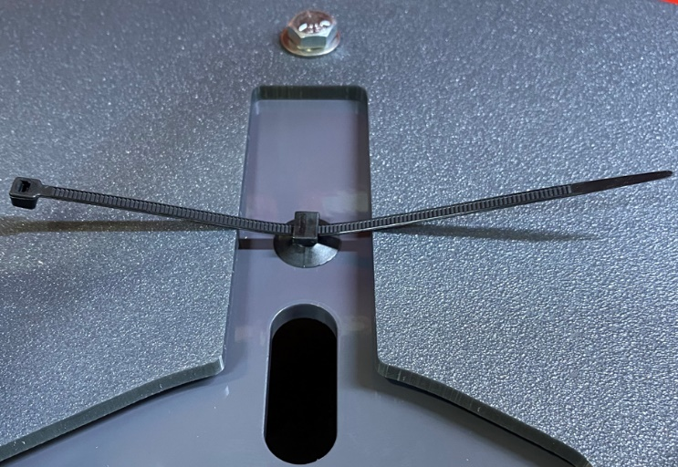
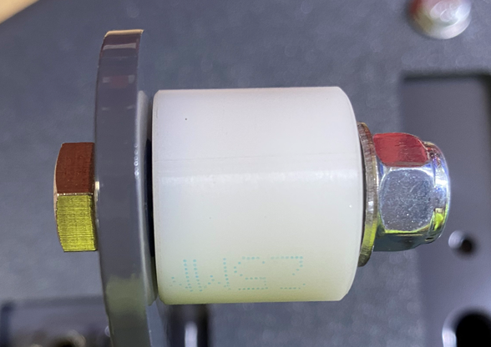
  - Attach a bumper wheel (E28598) to the frame weldment using a hex bolt (E29513), 3 flat washers (E28622), and a nut (E28623). The washers go under the bolt head and between the wheel and the weldment and under the hex nut. The wheel should be able to rotate once tightened. A little movement in the bolts head is not a big deal.
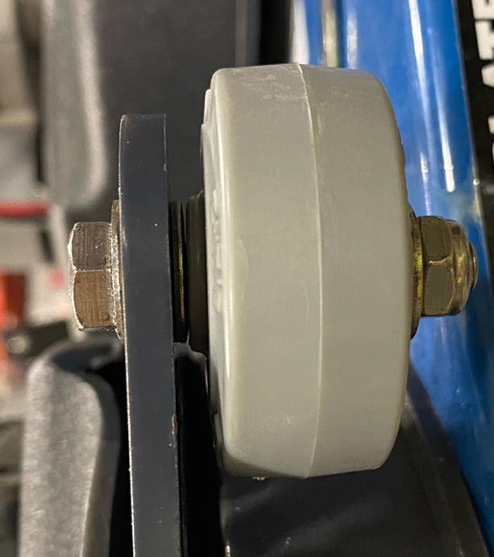

  - Place 1 motor (E29017) onto the table with the shaft pointing up. Keep the green band it. Use the template provided for motor orientation. **As a temporary step, the red and black wire on the brush motor need to be flipped to ensure the motor spins the correct direction.**

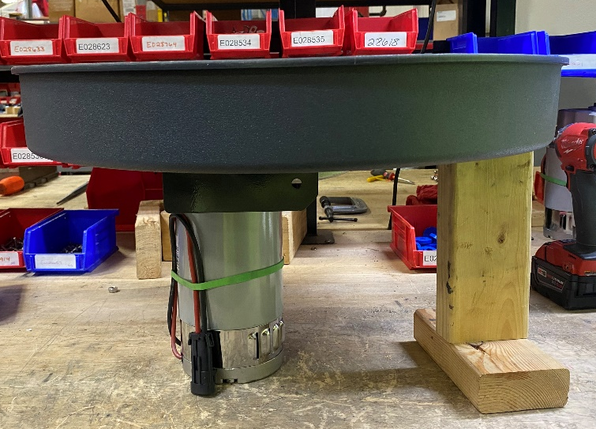
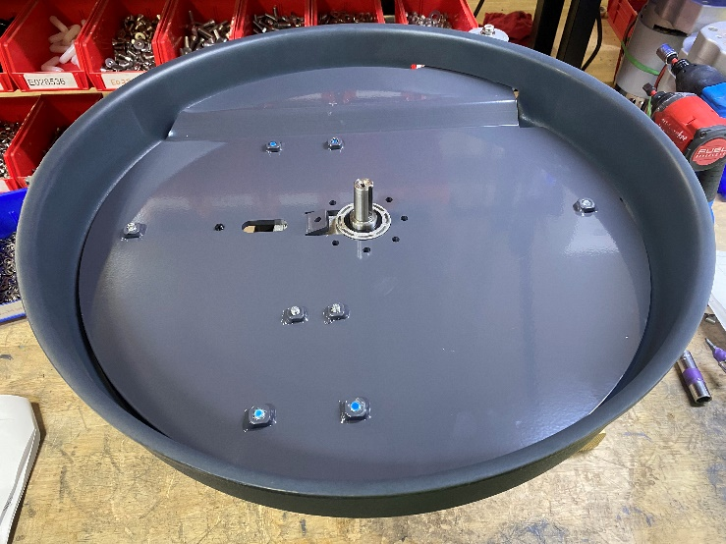
  - Flip the head assembly over and place it onto the motor. Ensure the motor is in the proper orientation.

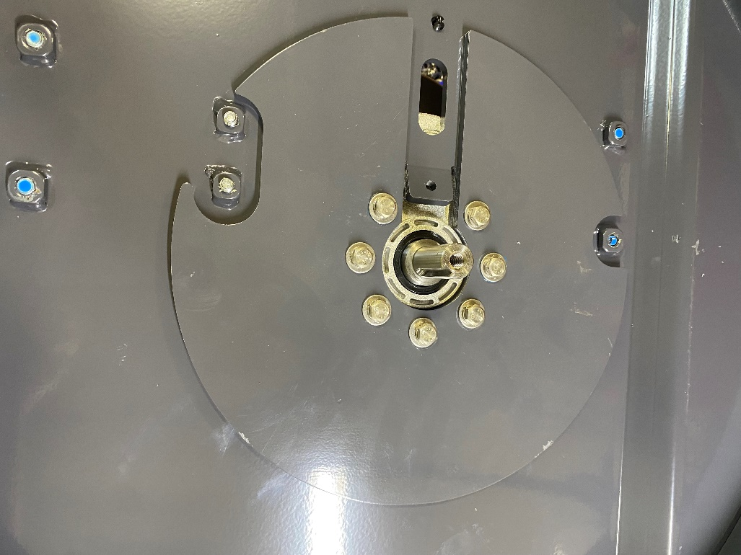
  - Place a weight (E28856) and attach the head assembly to the motors using Blue Loctite, 7 hex bolts (E29386), 7 washers (E28617), and 7 lock washers (E29385). Tighten the bolts to 7 ft-lbs. min. Mark the orientation of the bolt head.

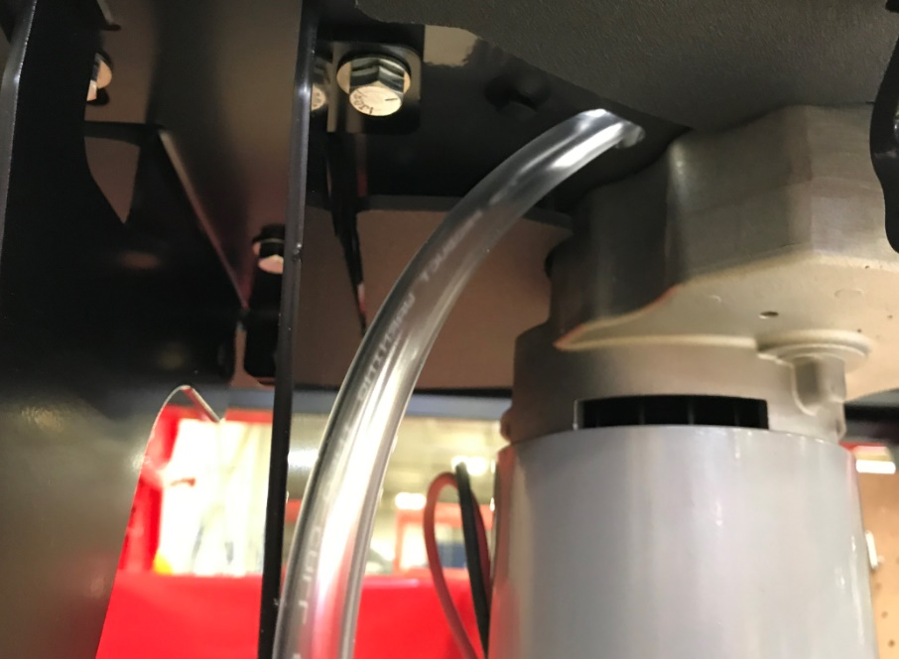
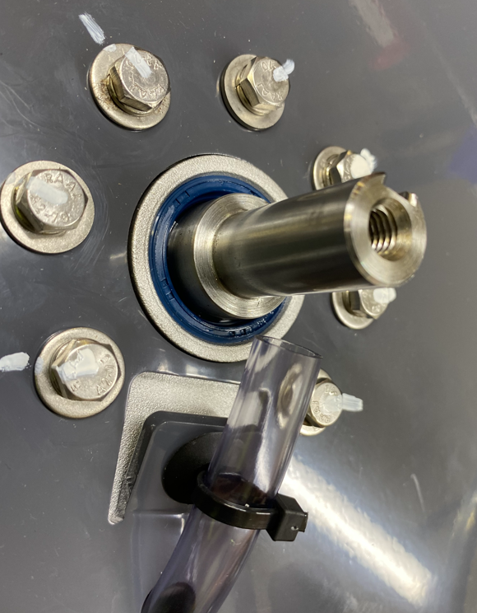
  - Cut a piece of 3/8” tubing (E28609) that are 18” long. Place wire tie mount in the hole then feed through the hole in the deck as shown. Position the end of the hose so that it is about ½” from the motor shaft. Attach the hose with a zip tie (E83523) to the zip tie mounts on the bottom of the deck.
½”
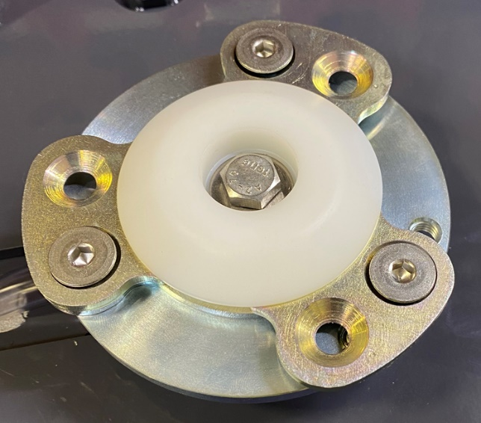
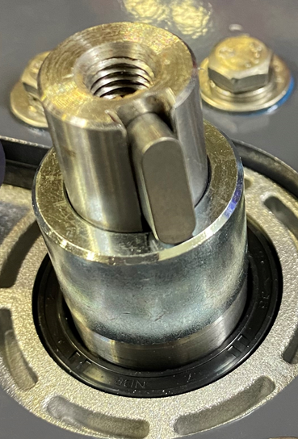
  - Place a spacer (E29042) over the motor shaft and a key (E28911) into the groove. Put some anti-seize compound on the motor shaft. Attach a disk head coupler to the shaft using a hex bolt (E29426) and a washer (E29438). Use blue Loctite on the bolt. Tighten the bolts to 15 ft-lbs. Mark the orientation of the bolt head, washer, and hub with a straight line. When attached you will need to slightly bend the tabs on the disk head coupler to ensure pad can attach and detach properly.
Bend
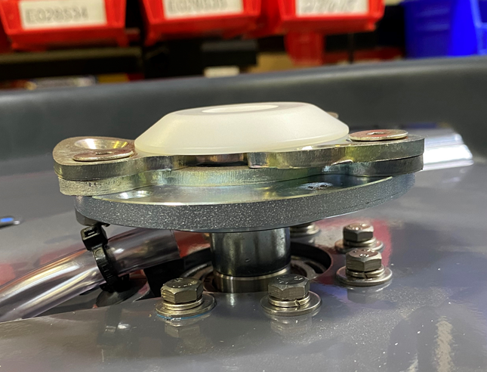

  - The hose water feed lines should be right next to the coupler shaft and pointing into the holes in the disk alignment coupler.
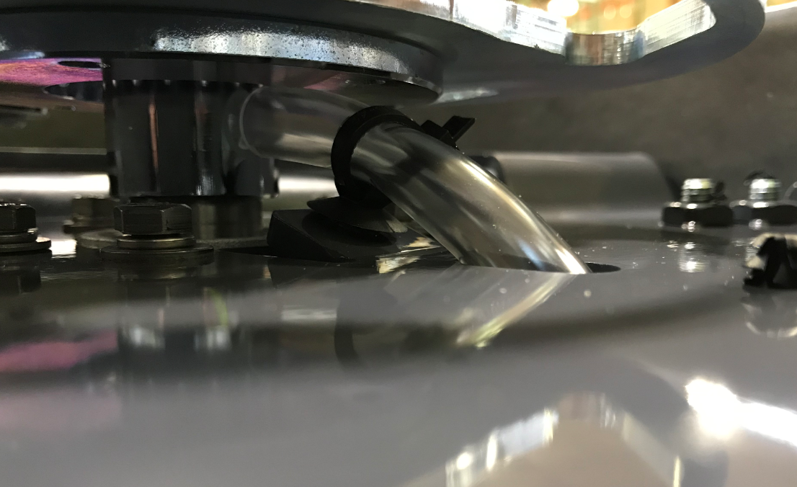
Hose is next to the coupler shaft and feeding into the holes that lead to the floor
  - Flip the head assembly back over.

- References (optional section as needed)

- Training Guide

Functional Training Groups Requiring Training
Equipment Assembly Group

- SOP Change Control

Date of Change | Reason for Change
TBD | This is the first version of the S.O.P. hence there are no revisions to this document.
4/2/2025 | Updated and re-formatted

Approvals

Submitter/Author Approval:__________________________________ Date:______________________

Management Approval:______________________________________ Date:______________________

QAU Approval:_____________________________________________ Date:______________________

